***Study Plan For*: How do redox conditions and O2 availability influence soil C stocks, inorganic N pools and fluxes, and P pools across a wet tropical forest topographic gradient?**

November 21, 2015

*Sections included here:*

* Introduction
* Hypotheses/justification
* Study plan brief approach
* Methods details
* Significance and desired outcomes

*What else is Christine supposed to deliver? a.k.a. forthcoming things:*

* This is a rough, rough, rough draft of this study plan… nearly everything needs to be altered/amended
* Ideally, I’d love big-picture feedback about whether or not you think this is (a) worthwhile, (b) on the right track, (c) missing something huge I haven’t thought of.

Christine S. O’Connell

University of California-Berkeley

Silver Lab

Dept. of ESPM

**How do redox conditions and O2 availability influence soil C stocks, inorganic N pools and fluxes, and P pools across a wet tropical forest topographic gradient?**

*Keywords: redox conditions, oxygen availability, soil moisture, nutrient cycling, ecosystem thresholds*

**Introduction:**

Abiotic conditions – including soil mineralogy, moisture content, and reduction-oxidation (redox) conditions – have long been understood to exert influence on the cycling of carbon (C), nitrogen (N) and phosphorus (P). However, considerable uncertainty surrounds how soil nutrient cycling differs between upland, tropical soils that feature dynamic redox conditions and adjacent soils that do not. Shifting redox conditions can change the amount of available P in soils: iron (Fe) reduction can liberate previously unavailable P, making it available for the microbial or plant community (Liptzin & Silver, 2009). Conversely, Fe(III) reduction has been shown to lead to a loss of N via the production of N2, making N relatively less available to microbes and plants (Yang *et al.*, 2012). In tropical upland soils, rates of Fe(II) production can account for large proportions of organic C oxidation (Dubinsky *et al.*, 2010) and redox conditions may change the rates at which soil microbes decompose organic C (Hall *et al.*, 2012; Hall & Silver, 2013).

Global change models that feature coupling between the C, N and P cycles rely on accurately described relationships between topography, soil type and nutrient cycling. In wet tropical forest soils, the interaction between landscape position, soil moisture, oxygen (O2) availability and redox potential can lead to differences in nutrient cycling not only between tropical forest landscapes, but also across relatively small topographic gradients within a given forest. Quantifying how C, N and P cycling responds to fluctuating redox conditions in upland tropical forest soils can inform modeling environments that are sensitive to N and P availability.

In this study, we take advantage of high-resolution, temporal datasets that document the dynamic belowground conditions across a topographic gradient in Luquillo Experimental Forest (LEF), Puerto Rico. *We plan to document the soil abiotic conditions and nutrient availability across a topographic gradient, as well as down the soil profile, and quantify patterns in how O2, redox, topographic position and soil moisture correlate with key C, N and P cycling variables.*

**Study plan approach/hypotheses:**

I will conduct this research under the mentorship of Professor Whendee Silver (UC Berkeley), who has decades of experience researching the dynamics of wet tropical forests at the LEF and in Puerto Rico. LEF has heavy year-round precipitation (mean annual rainfall of 3500 mm/year (Wood & Silver, 2012)) and substantial topographic variation.

The proposed study utilizes an established array of soil moisture and oxygen sensors across a ridge-to-valley slope in LEF. Further, it adds redox sensors to the established array and installs moisture, oxygen and redox sensors within soil depth profiles. Finally, it complements that high-resolution dataset with targeted soil sampling to measure C, N and P cycling variables.

We address two core questions:

Question 1: How do soil N and P availability correlate with soil oxygen, moisture and redox conditions across a topographic gradient?

*Hypotheses:*

(1.1) N will be affected like AAA.

(1.2) P will be affected like AAA.

(1.3) Fe? pH? What else?

Clearly, Christine hasn’t written this part yet.

Question 2: How do soil C and microbial community patterns correlate with soil oxygen, moisture and redox conditions across a topographic gradient?

*Hypotheses:*

(2.1) C will be affected like AAA.

Clearly, Christine hasn’t written this part yet either.

*General approach:*

To address these questions, we will record soil moisture, O2, and redox potential at 35 soil surface observation points in LEF (Figure 1). The surface soil sampling array has five transects associated with topographic locations: ridge, upper slope, mid slope, low slope, and valley transects. Each transect has 7 sensor locations (5 transects * 7 locations/transect = 35 observations). Each sensor location is, more precisely, the location of three sensors, one to record soil moisture, a second to record soil O2, and a third to record redox potential. Data is recorded hourly (Figures 3-5).

Additionally, we will install three soil depth profiles (Figure 2), in which the same sensors (soil moisture, O2, and redox) will be installed at 6 depths (15, 30, 45, 60, 75, and 90 cm). We will install three soil depth profiles: one on the ridge, one at the mid-slope, and one in the valley of the surface soil array.

Finally, we will conduct soil sampling along the ridge, mid-slope and valley transects and from soils at depth in order to combine high-resolution data on abiotic soil conditions with a snapshot of the differences in C, N and P cycling across topography and soil depth.

This is the sketchy first-pass. Whendee, here is where I start straight-up brainstorming what would be a very cool way to set this up, but I got a little overexcited and need help reigning this in to an appropriate scope (however, if you think the below is appropriate, I am all about doing tons of work to make these soil measurements happen!).

**The building blocks of what we would measure:**

* 35 nodes with O2, moisture, redox, and collected soil (soil samples from 0-15 cm, 15-30 cm, BD from each; 2 depths * 35 locations = 70 soil samples).
* 3 soil depth profiles with O2, moisture, redox, and collected soil from 0-1 m, including bulk density (BD).  12 additional soil depth profiles where we just collect soils one time so that we have the Silver Lab approved 4-5 replicate samples (6 depths * 3 topographic gradient locations * 4 replicates = 50 soil samples).
* Collected soil and one-time gravimetric and BD measurements from 2 m at each of the soil depth profile locations (3 topographic gradient locations * 4 replicates * 1 depth = 12 soil samples). (This is just because I think it would be a nice addition while we were down there with an auger to get some data from below 1 m on the books.)
* These three building blocks together: Build a full 3-D profile of how C, N, P, redox, O2 and moisture vary across this gradient during the wet season of this tropical forest.  Ideally, resample soils again when moving the array to another location so that we have two time points, since we’ll be digging the whole thing up anyways and it won’t matter if we disrupt the array soil at that point.

**What to do with the soils:**

Christine would collect and bring back 50 + 70 + 12 soil samples = 132 samples (e.g., an epic bucket load).  Soils get split into soils to dry, fresh soil to go to JP’s group, and fresh soil to stay with the Silver Lab.  She’ll bring back XX g in each sample.

*Christine and Whendee’s paper (nutrient patterns):*

- Redox/O2/moisture patterns

- Bulk density, pH

- KCl extractions pre- and post-incubation —> N pools and fluxes

- P pool fractions (modified Hedley?)

- C pool fractions (maybe not in this paper?  see below)

*JP, Christine and Whendee collab (carbon patterns?  microbial patterns? whatever JP is thinking?):*

- Microbial community analyses

- Maybe C fractions should/could go here instead?  Though I’d love to learn about this.

- What else would we like to see in here?

**Analyses:**

Christine and Whendee’s paper:

- I imagine this primarily looking at patterns in how O2, redox, topo position and moisture correlate with nutrient cycling - so, lots of correlations

- We’d also do analyses of variance to look at whether different nutrient cycling variables differ significantly by topographic location or depth

**Silver Lab context for the study:**

Before pulling the trigger on this, I will email ORNL collaborators to ensure that we’re not missing something key that they would want us to measure.

Ideally, I hope that rigorously measuring these patterns across space and the relationship between abiotic conditions and key nutrient cycling variables, we’ll be well set up to decide what to test in the redox manipulation experiment that Whendee and Christine talked about running back at Cal (Ryan can collect soils and ship them when we’re ready to do this - I prefer to wait until we have initial results from the patterns work before diving in to a major lab campaign so we don’t design it blind).

**Methods:**

Christine still needs to write this when we decide on what is making the final cut.

**Desired outcomes:**

*Desired outcomes*: I see two key outcomes coming from this project. First, I will aim to efficiently and rapidly “get a handle on” the field context in PR during my initial months at Cal (check! Already happening!). Second, I expect that a manuscript will be written based on this project, which I initially anticipate could be aimed at a mid-tier soils or ecosystem ecology journal. I’m also excited to establish a productive collaboration with JP.

*Broader impacts*: I would like to write up a lesson plan for an 8th grade classroom on the “ecology of soils” that compares California soils to soils in a tropical forest. I’ve also thought about framing the lesson as the “ecology of drought” and comparison a CA drought to a PR drought, though that’s not entirely related to the above. In either case, I will work with a friend (Tom McFadden) who teaches at San Mateo’s Nueva School to target the lesson appropriately and come visit his classroom when it works for his class schedule.

**Figures**

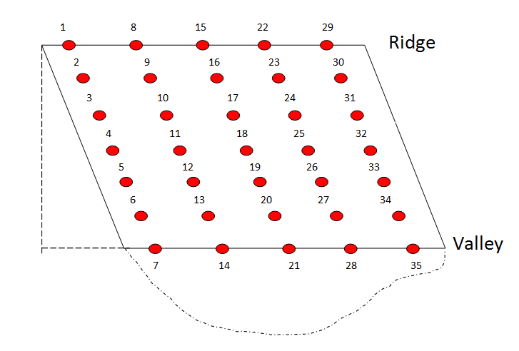

**Figure 1**. Soil moisture and O2 sensor locations across a topographic gradient in LEF. The sampling array has five transects associated with topographic locations: ridge, upper slope, mid slope, low slope, and valley transects (transects go left to right in the schematic here). Each transect has 7 site locations (5 transects * 7 locations/transect = 35 observations). Each site location is, more precisely, the location of two sensors, one to record soil moisture and a second to record soil O2. Data is recorded hourly.



**Figure 2**. Potential locations for the soil depth profile installations.

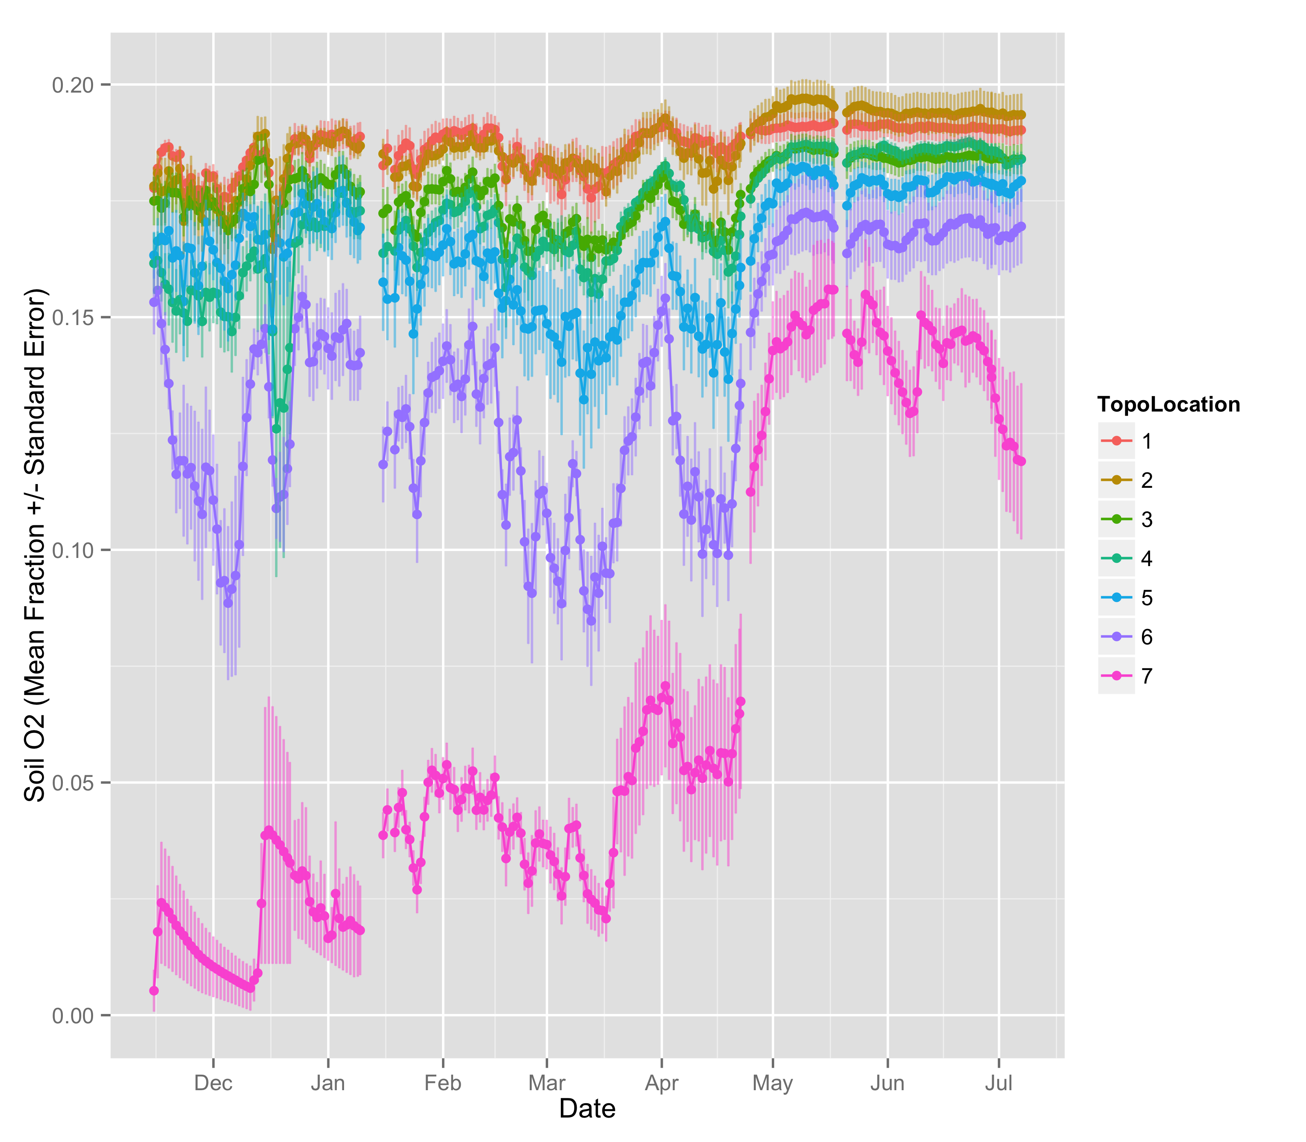

**Figure 3**. Initial data collection tracking soil O2 from pre-drought through the onset of drought (mid-April). Clear topographic patterns have emerged in how rapidly oxygen availability increases in some sites over others after drought conditions begin. Variability also differs across topography, with the valley sensors seeing larger standard error values.

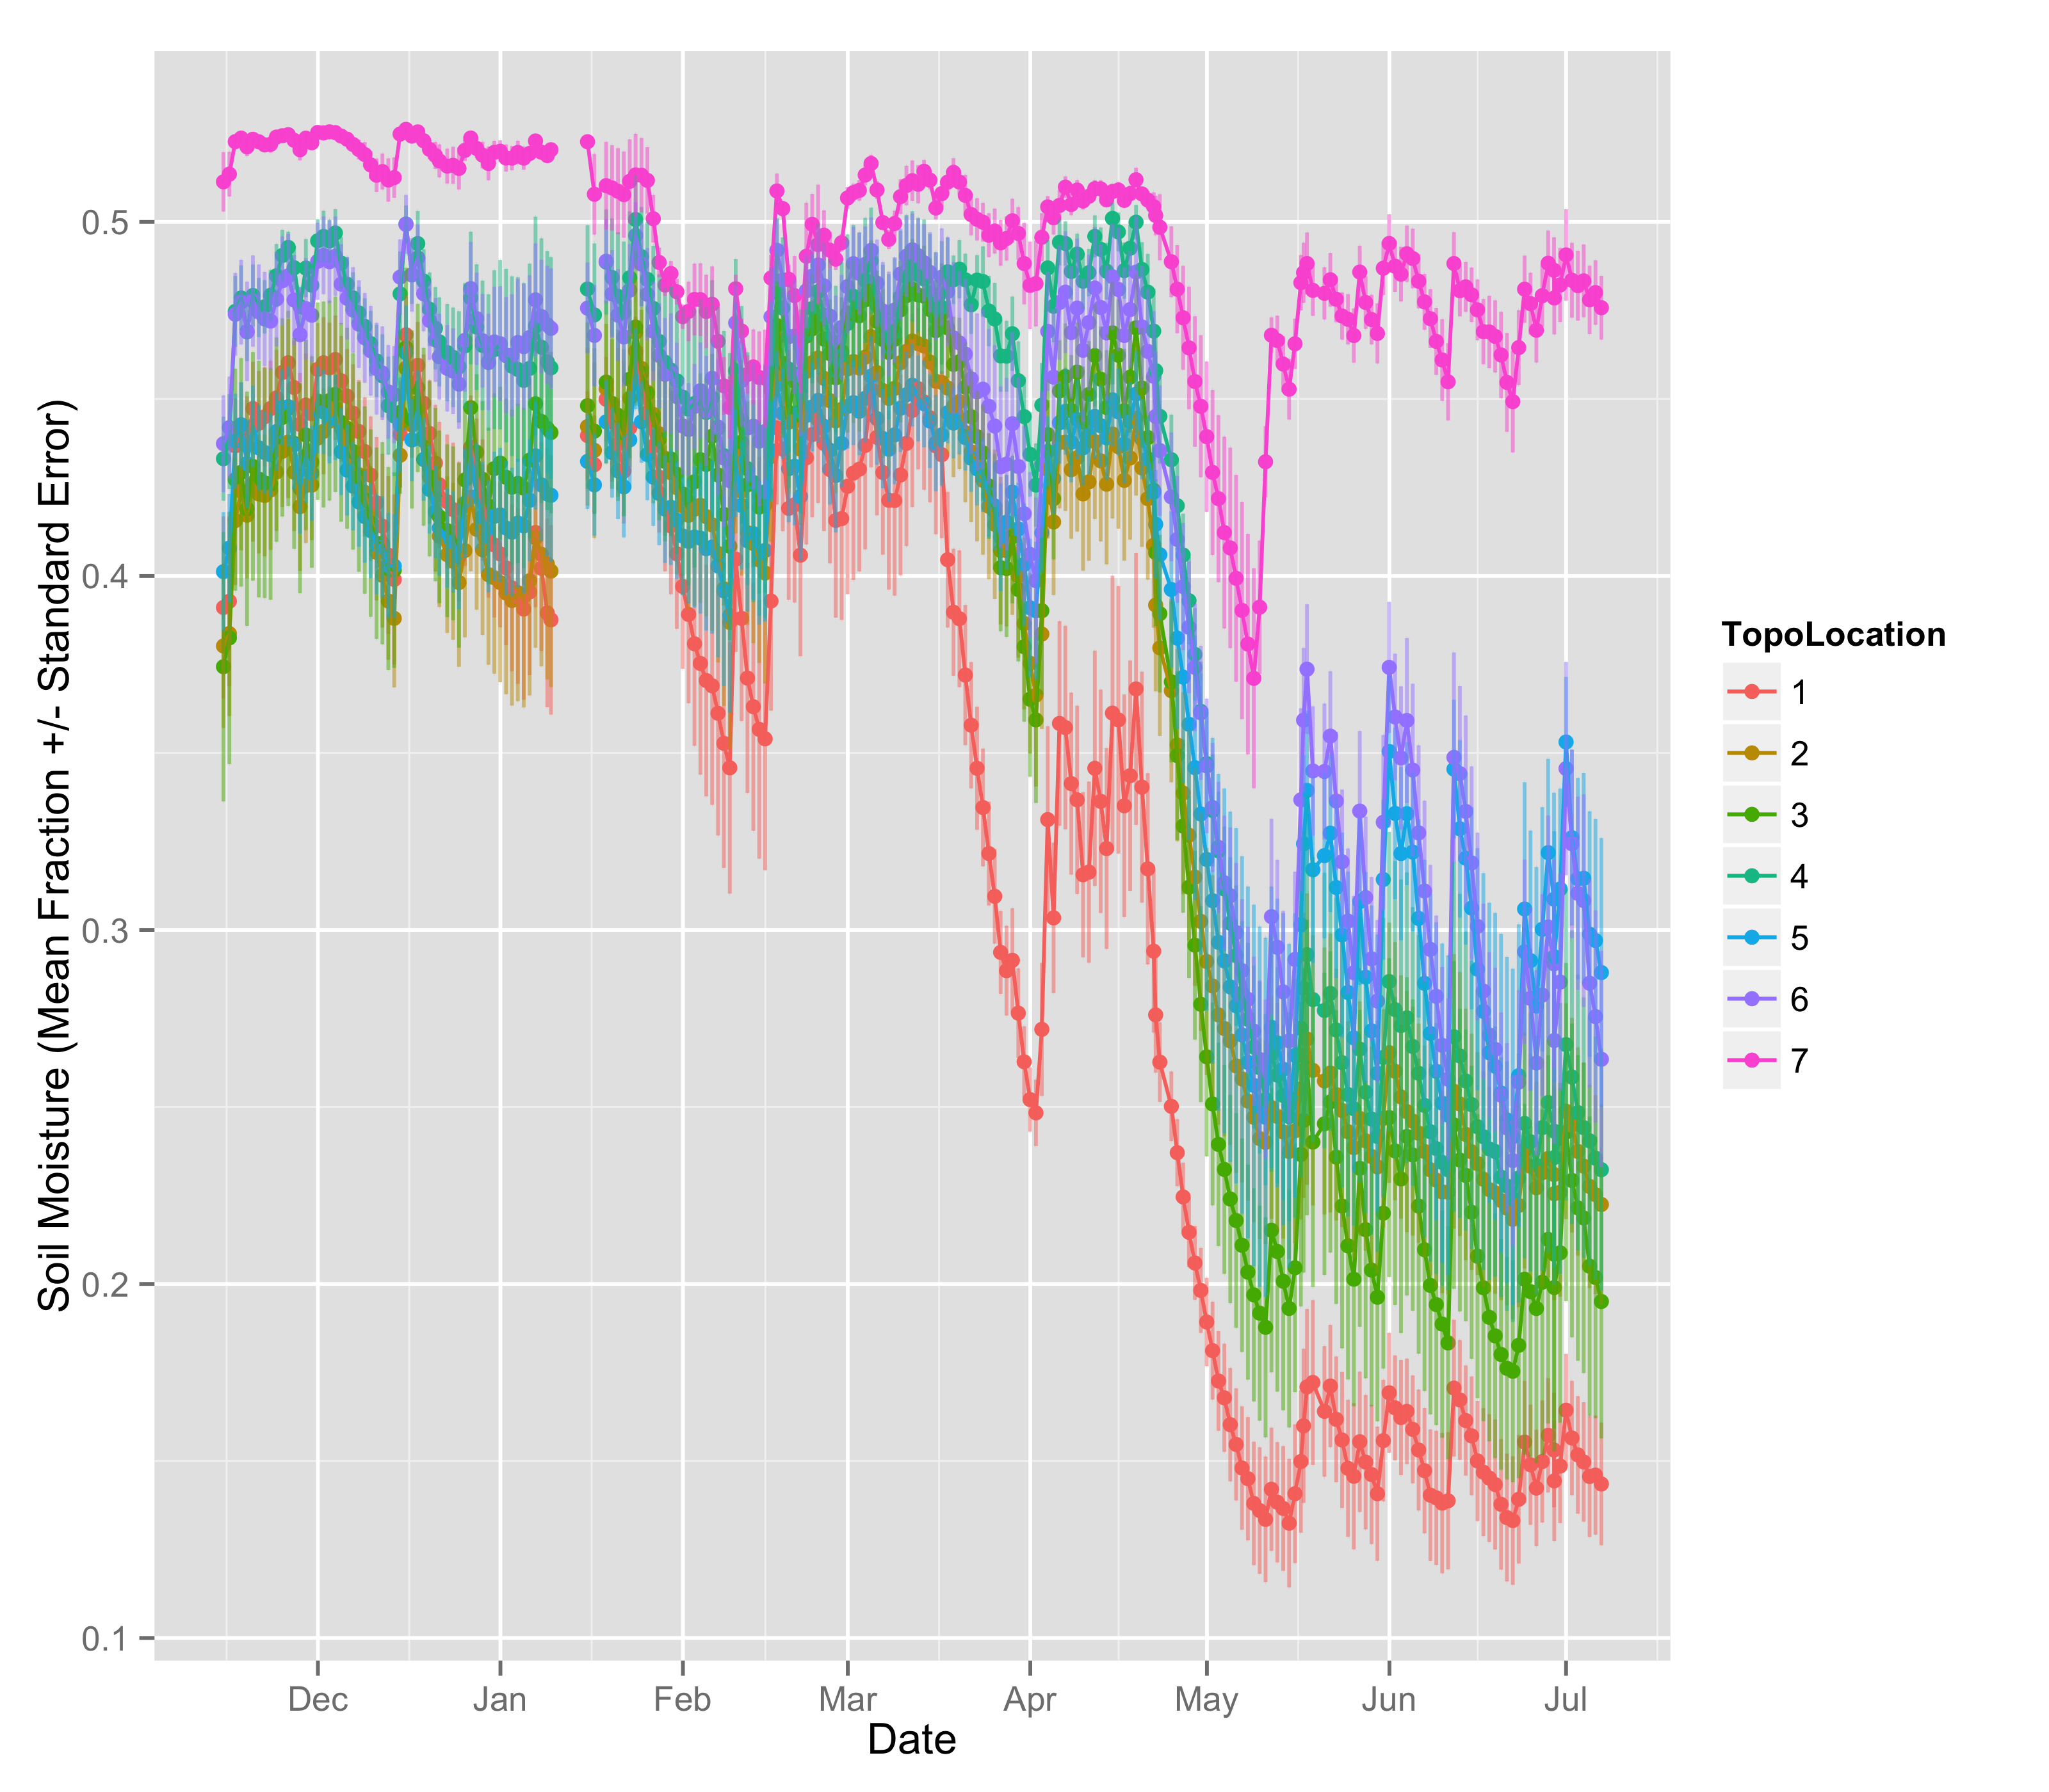

**Figure 4**. Initial data collection tracking soil moisture from pre-drought through the onset of drought (mid-April). Valley sites lose moisture less so than slope or ridge sites.

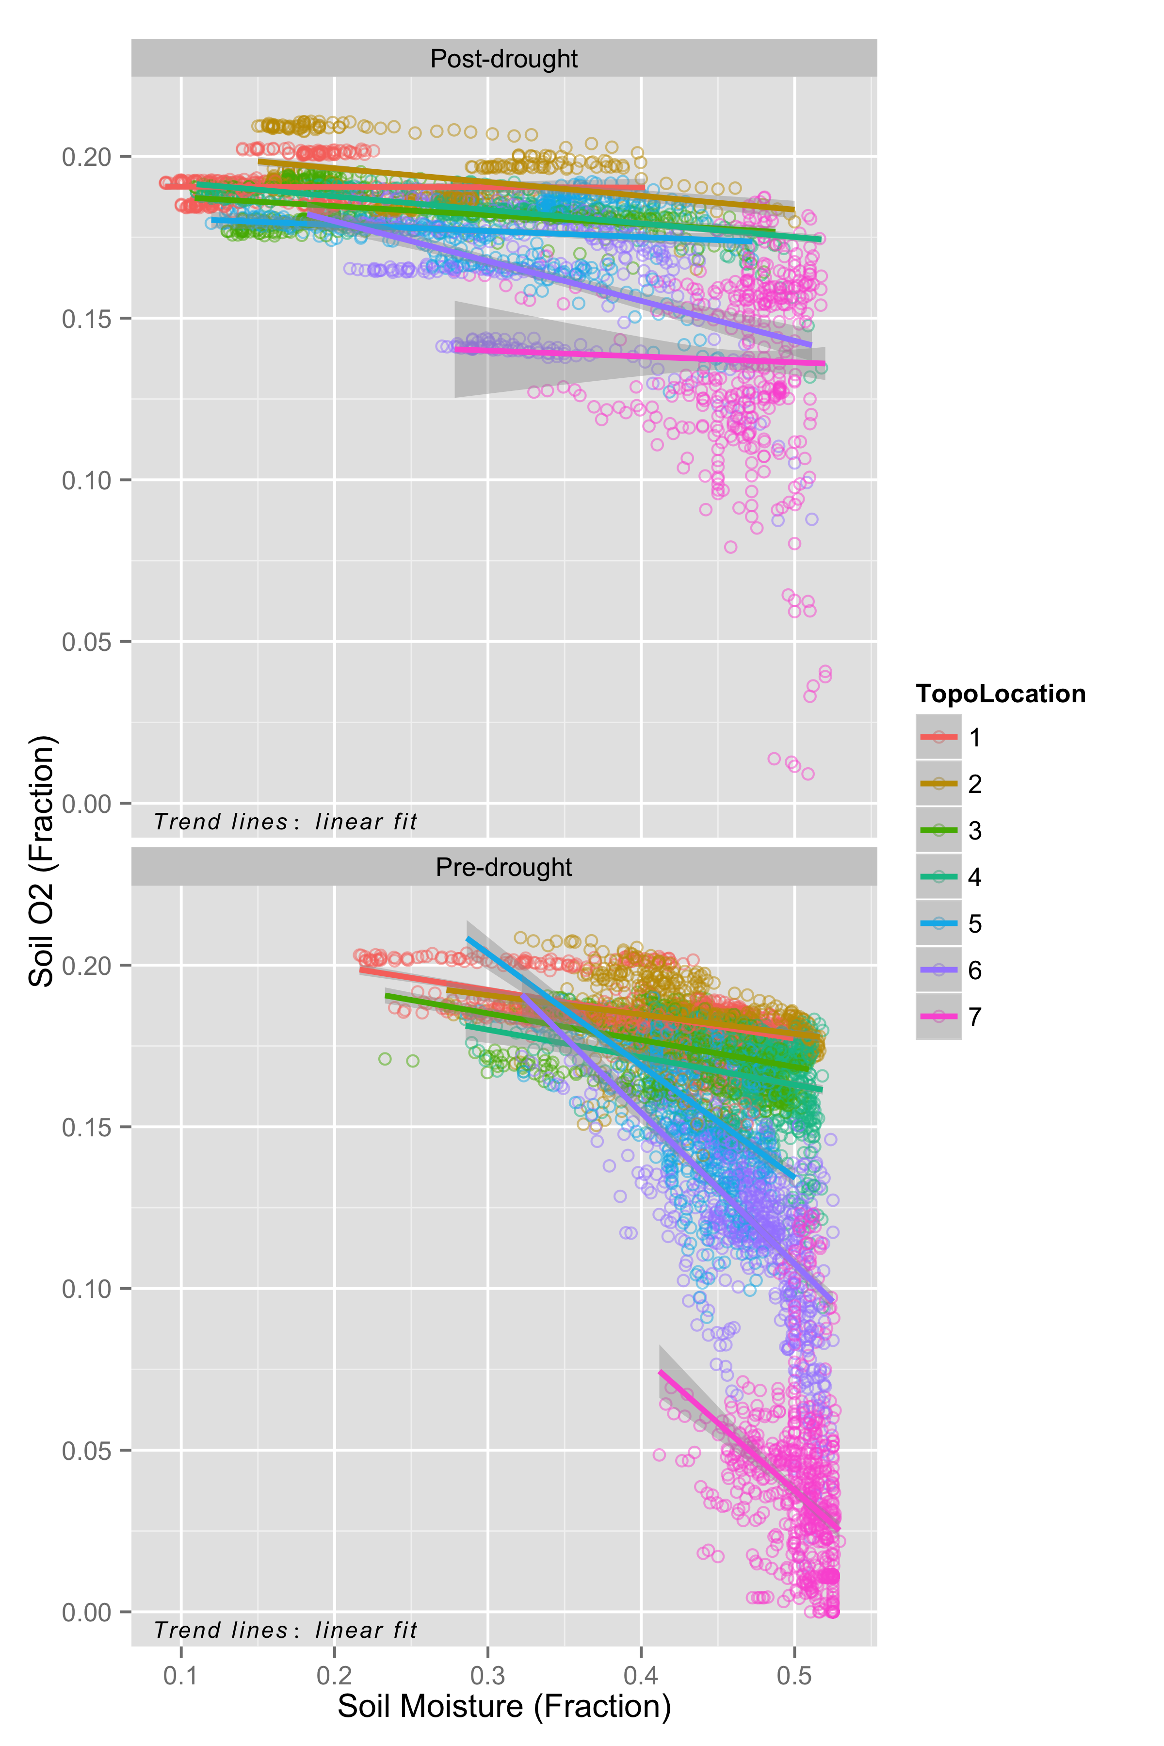

**Figure 5**. Write a better caption. This is just for Christine to check out how the O2-moisture relationship changes across the topo grandient and pre- and post-drought. Weird that the valley’s relationship between soil O2 and moisture flattens post-drought. ???

**Works Cited**

Bonan GB (2008) Forests and Climate Change: Forcings, Feedbacks, and the Climate Benefits of Forests. *Science*, **320**, 1444–1449.

Dubinsky EA, Silver WL, Firestone MK (2010) Tropical forest soil microbial communities couple iron and carbon biogeochemistry. *Ecology*, **91**, 2604–2612.

Hall SJ, Silver WL (2013) Iron oxidation stimulates organic matter decomposition in humid tropical forest soils. *Global Change Biology*, **19**, 2804–2813.

Hall SJ, McDowell WH, Silver WL (2012) When Wet Gets Wetter: Decoupling of Moisture, Redox Biogeochemistry, and Greenhouse Gas Fluxes in a Humid Tropical Forest Soil. *Ecosystems*, **16**, 576–589.

Jackson RB, RANDERSON JT, Canadell JG, et al. (2008) Protecting climate with forests. *Environmental Research Letters*, **3**, 044006.

Neelin JD, Münnich M, Su H, Meyerson JE, Holloway CE (2006) Tropical drying trends in global warming models and observations. *Proceedings of the National Academy of Sciences*, **103**, 6110–6115.

Pan Y, Birdsey RA, Fang J, et al. (2011) A Large and Persistent Carbon Sink in the World's Forests. *Science*, **333**, 988–993.

Saatchi SS, Harris NL, Brown S, et al. (2011) Benchmark map of forest carbon stocks in tropical regions across three continents. *Proceedings of the National Academy of Sciences*, **108**, 9899–9904.

Stocker TF, Qin D, Plattner G-K, et al. (2013) IPCC, 2013: Summary for Policymakers. *Climate Change 2013: The Physical Science Basis. Contribution of Working Group I to the Fifth Assessment Report of the Intergovernmental Panel on Climate Change*.

Wood TE, Silver WL (2012) Strong spatial variability in trace gasdynamics following experimental drought in a humid tropical forest. *Global Biogeochemical Cycles*, **26**, n/a–n/a.

Yang WH, Weber KA, Silver WL (2012) Nitrogen loss from soil through anaerobic ammonium oxidation coupled to iron reduction. *Nature Geoscience*, **5**, 538–541.